

***Department of Computer Science & Engineering***

**Course Title –** Software Engineering

**Course Code –** CSE 322

**Section** - A1

NLP based Laptop Recommendation System

***Final Report***

**Date of Submission –** April 17, 2022

**Submitted by:**

Md. Hasibur Rahman (19101009)

Tanmoy Mazumder (19101013)

Shawan Das (19101020)

**Submitted to:**

Dr. Shah Murtaza Rashid Al Masud

Associate Professor,

University of Asia Pacific

1. Introduction

The pandemic has forced the world to go on lockdowns multiple times in the past 20 months. Each time students and a large number of office workers had to shift to their tasks from home and this created an unprecedented surge in Computer sales, especially Laptops since laptops are more mobile compared to their desktop counterparts and they come with a pre-built video calling specs.

*Problem Statement*

As the number of sales of laptops increased, so did the number of complaints from the users that they had been ripped off at the store for not understanding the specifications. This has become more and more common as there are multiple things to be considered while buying a laptop and an average person has very little to no idea of these specifications, let alone which specs would be the perfect choice for their needs.

This problem can be tackled by searching online for reviews, as user reviews reflect a true image of how the product really is. However, this method falls short because of one problem: there are literally thousands of reviews online about hundreds of such devices.

2. Proposal

This project tries to overcome this certain problem using NLP (Natural Language Processing) and some Machine learning algorithms used on data collected through text-mining from online review sites. The core goals of the project:

* Collecting, cleaning and analyzing user review data from the internet
* Building a system with the most suited NLP model(BERT) capable of summarizing the human-written reviews
* Building an arsenal of well-summarized reviews for a user to get the perfect suggestion from.

3. Design

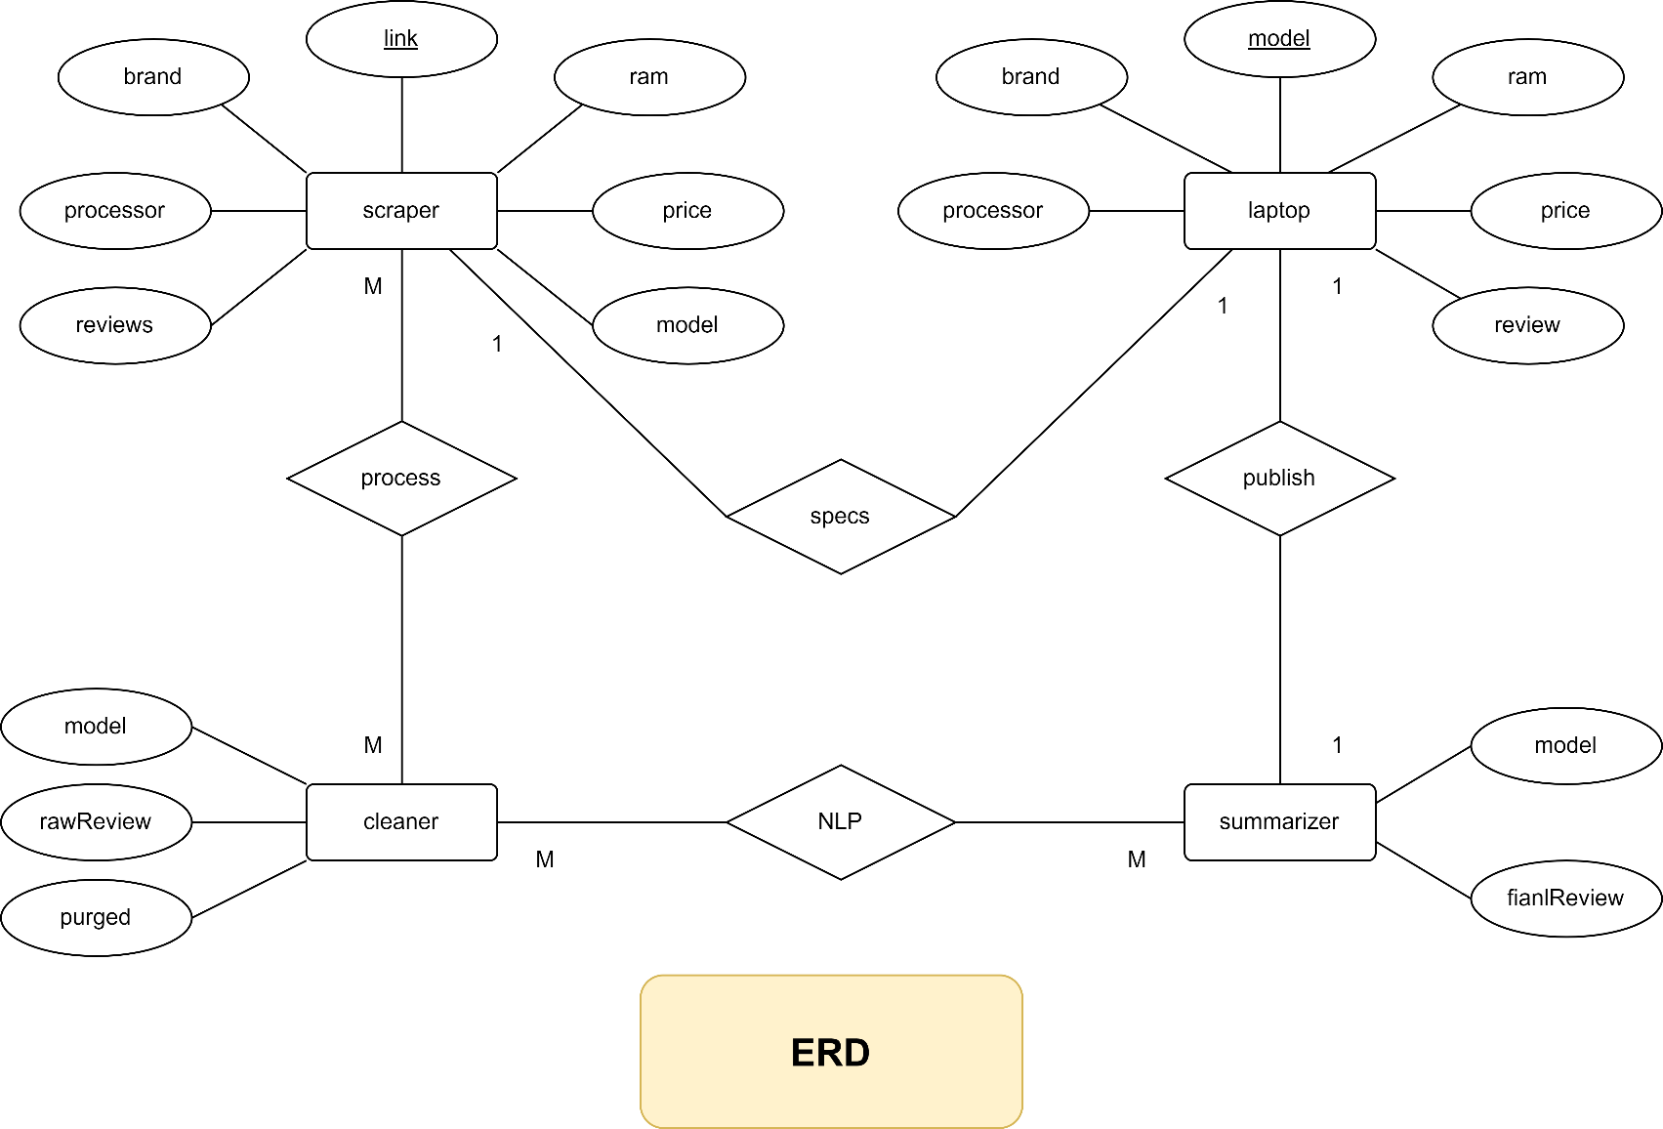Entity Relationship Diagram

­­­

Description:

There are 4 entities: Scraper, Cleaner, Summarizer, Laptop.

1. Scraper: The Scraper goes over each of the laptop’s review pages and collects information such as the model, reviews, price, brand, ram, and processor.
2. Cleaner: The cleaner processes the raw reviews collected by the scraper, purges the collected data of any unwanted portions that are hindrances to the NLP model’s functionality, and creates clean and usable versions of each review.
3. Summarizer: The summarizer comprises of the NLP model and the final review for the given laptop.
4. Laptop: This is the general entity for each of the laptops in the database. It holds the basic info from the scraper and the final review from the summarizer.

ERD Relations:

|  |  |  |  |
| --- | --- | --- | --- |
| **Entity A** | **Entity B** | **Relation** | **Type** |
| Scraper | Cleaner | Process | Many to many |
| Cleaner | Summarizer | NLP model | Many to many |
| Summarizer | Laptop | Publish | One to one |
| Laptop | Scraper | Specs | One to one |

Use Case Diagram

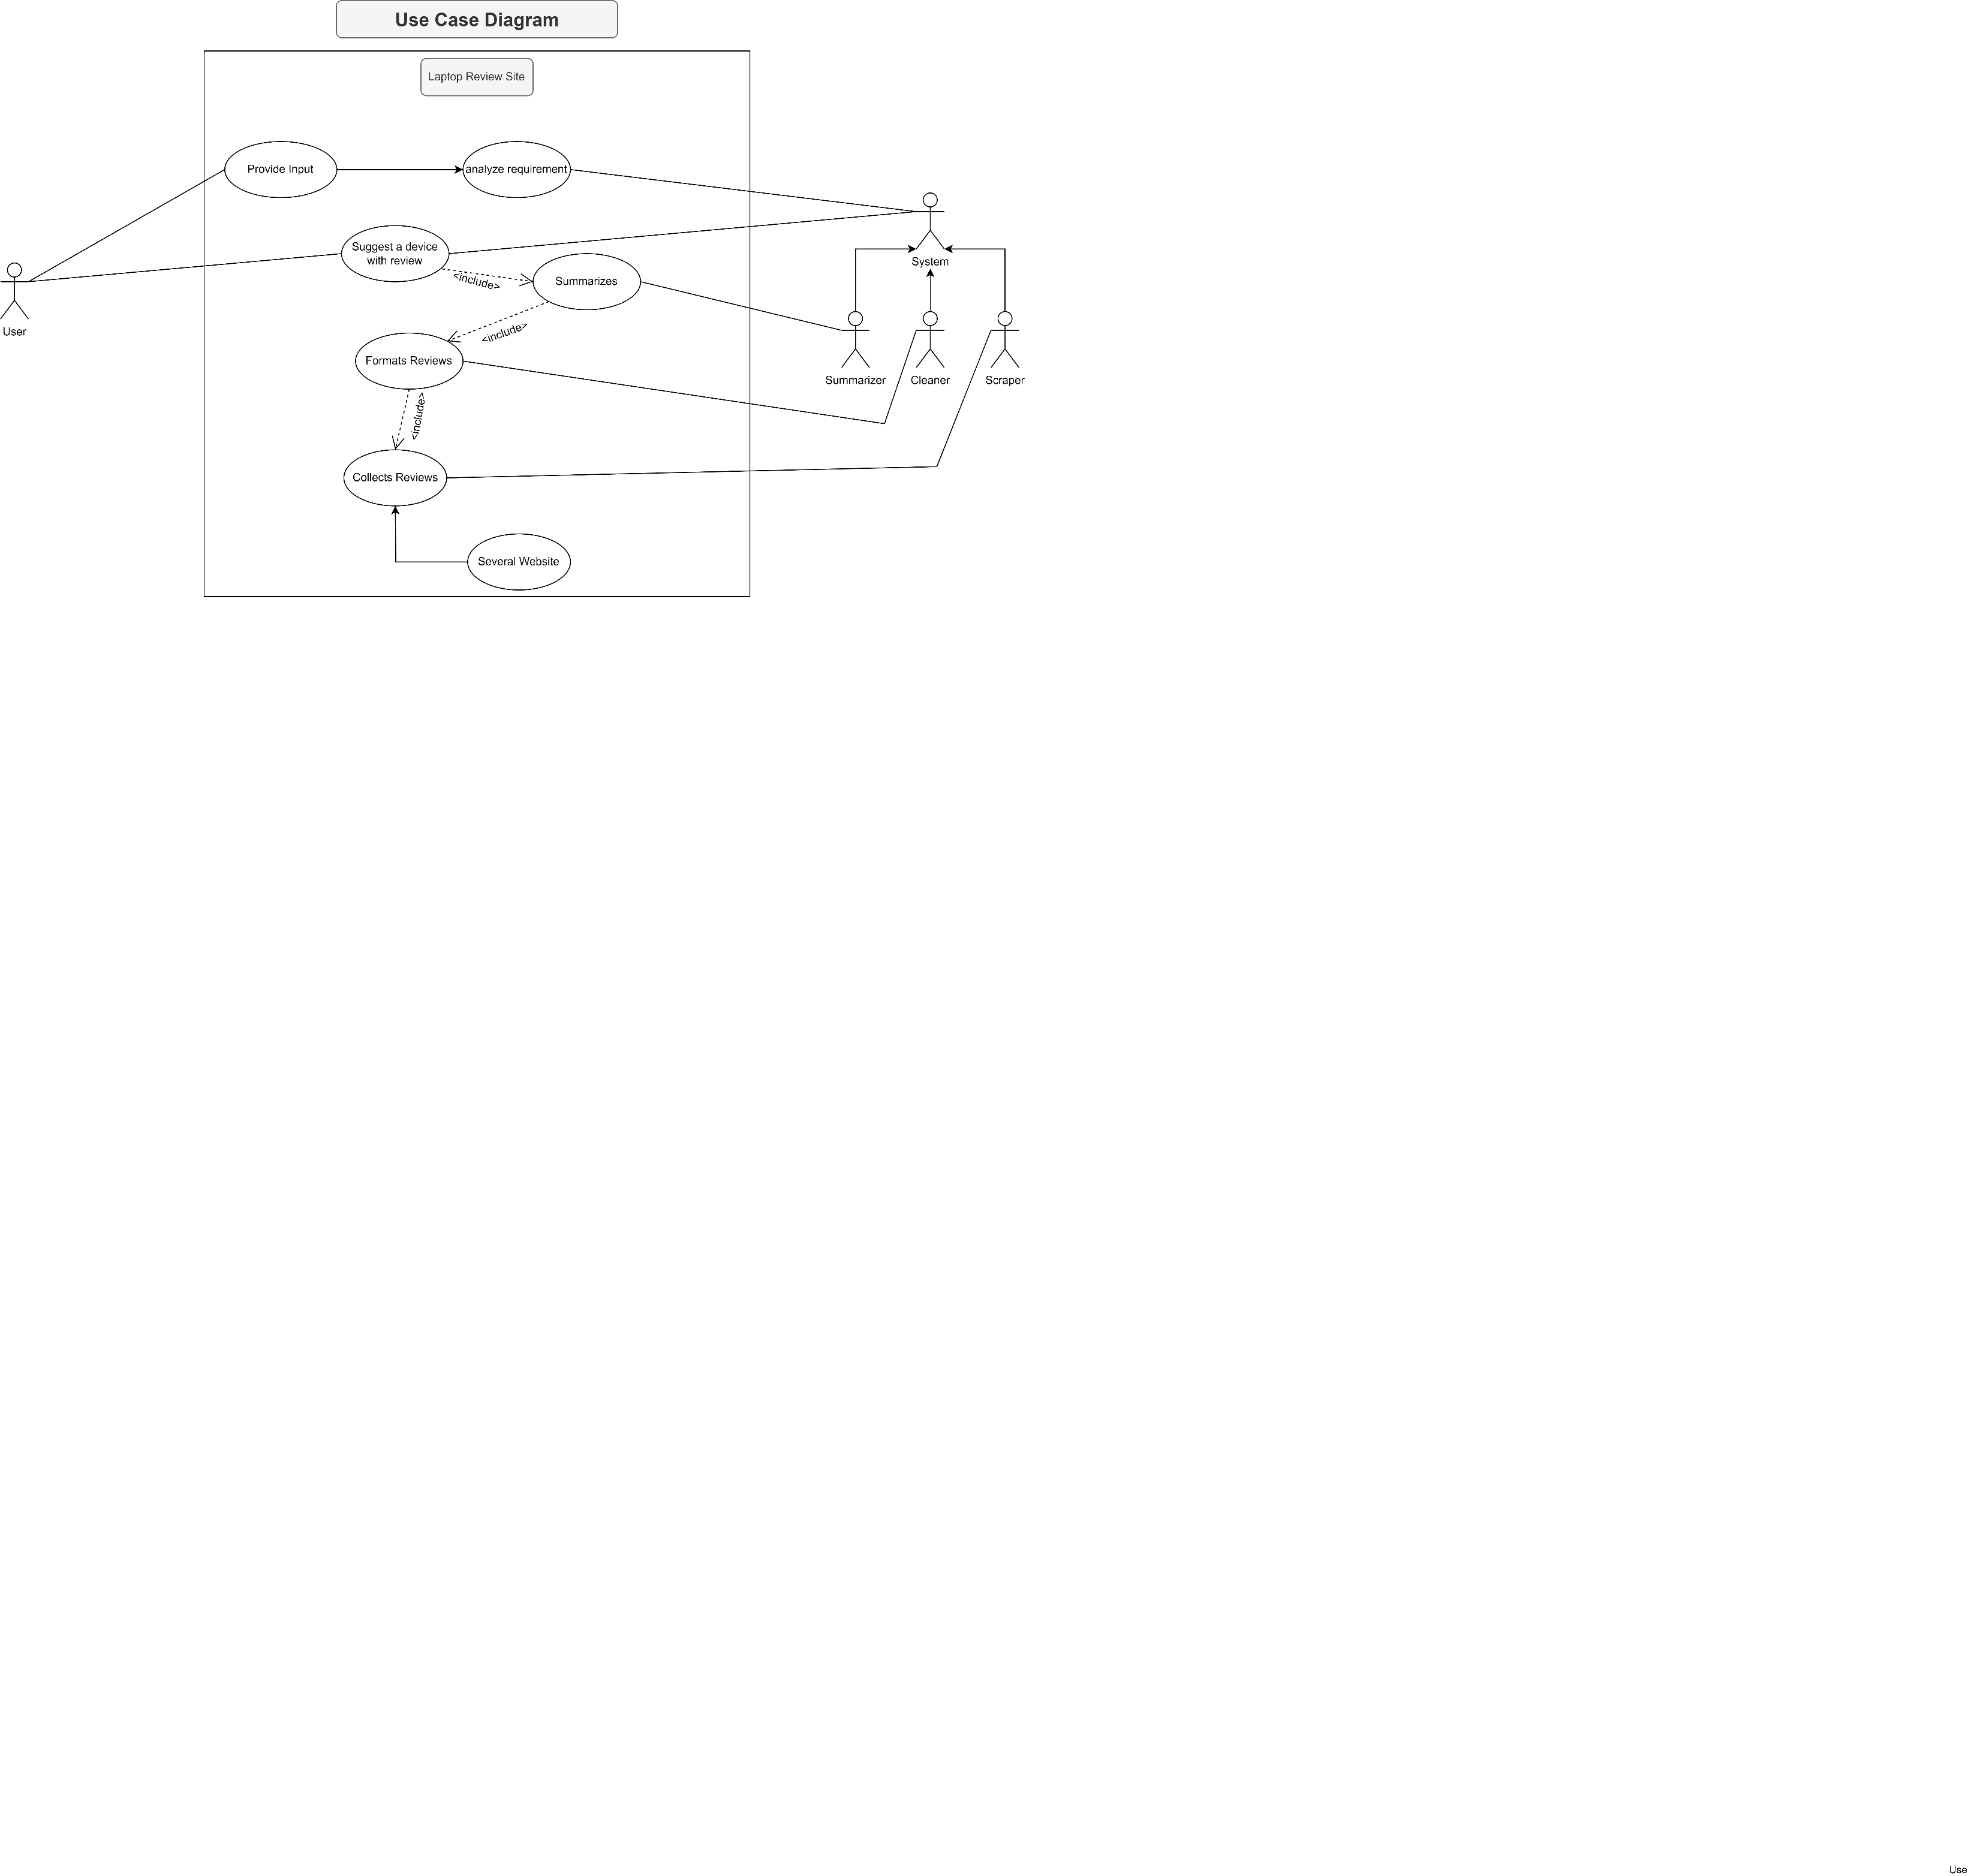

Description:

There are 2 actors: The User and The System(admin). They interact through the website.

The user provides input about what type of laptop they are looking for and then waits for the output. The input would then be analyzed by the system and it would provide suggestion by matching the best fit available from the summarized reviews.

These summarized reviews are the products of the subsystem Summarizer. The summarizer uses the multiple cleaned reviews provided to it by the Cleaner subsystem.  
The Cleaner subsystem is responsible for creating clean-formatted reviews from the raw reviews collected for each laptop.

The raw reviews are collected by the Scraper subsystem. The Scraper runs on the multiple links of review sites.

Following this process chain, the output suggestion would be created and provided to the user.

Activity Diagram

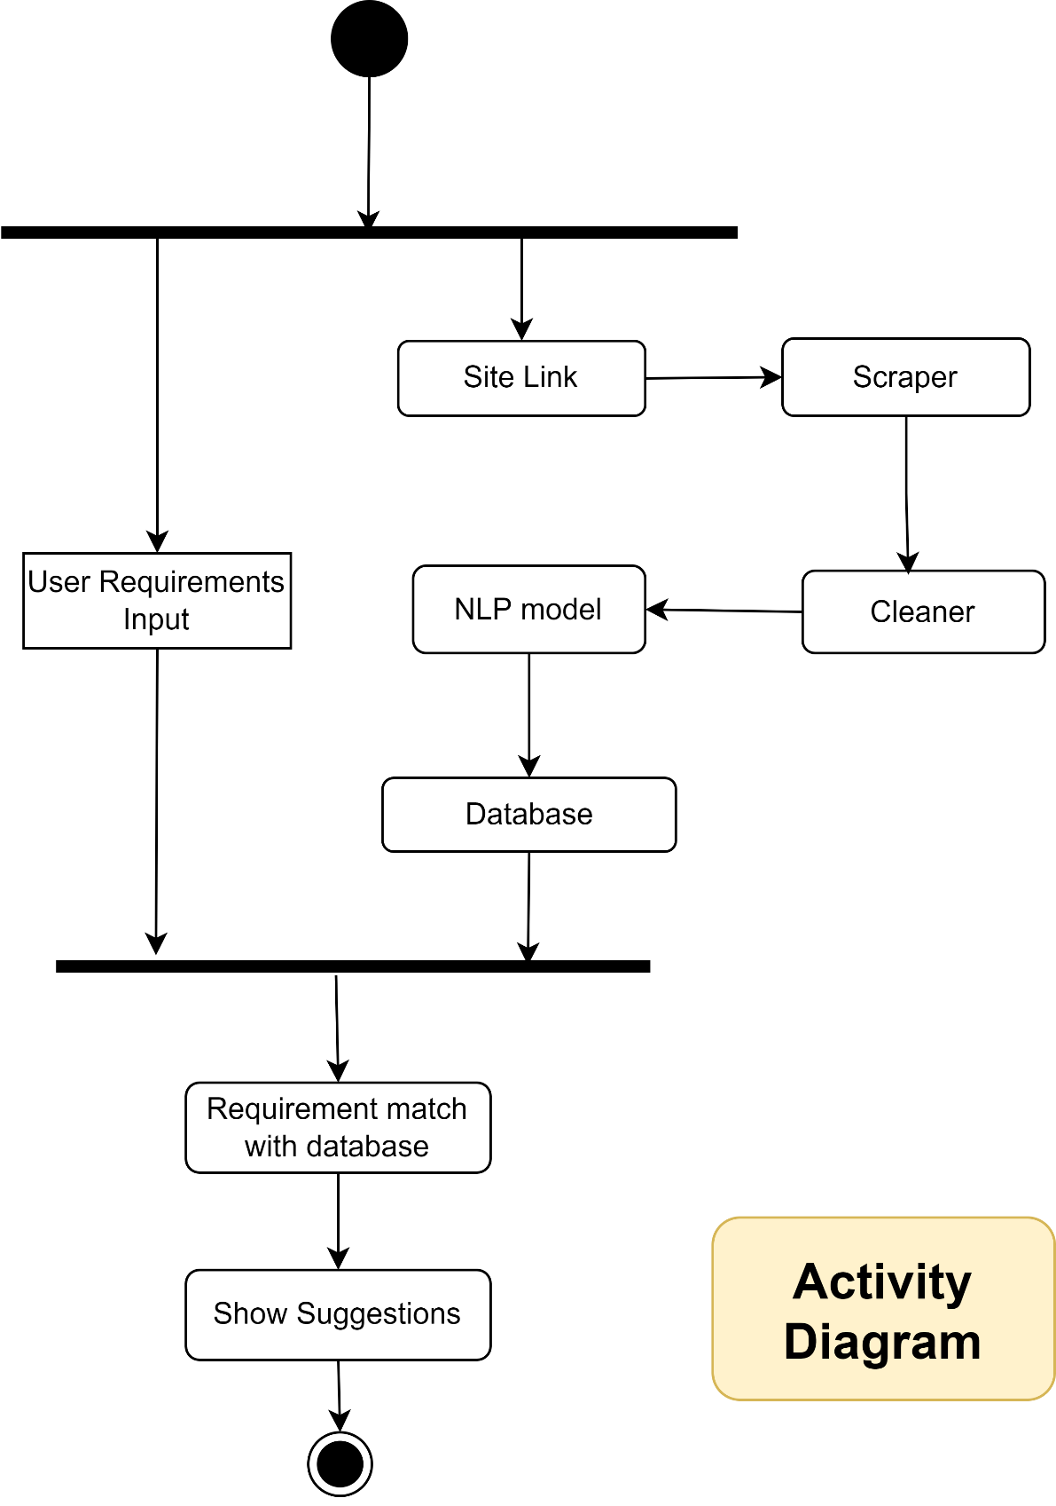

Description:

Each day, at a certain point in time, the system will run its scraper, cleaner, and NLP model’s summarizer in sequence to update the database.

Whenever a user uses the system and inputs their requirements, the system would run the request with the requirements parameters and match it with available laptop models and their review from the latest updated database. Once the system produces a result, it would be the output.

Sequence Diagram

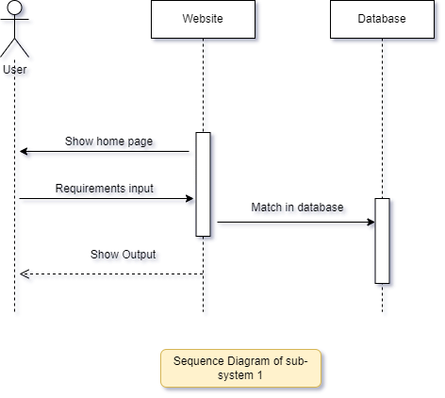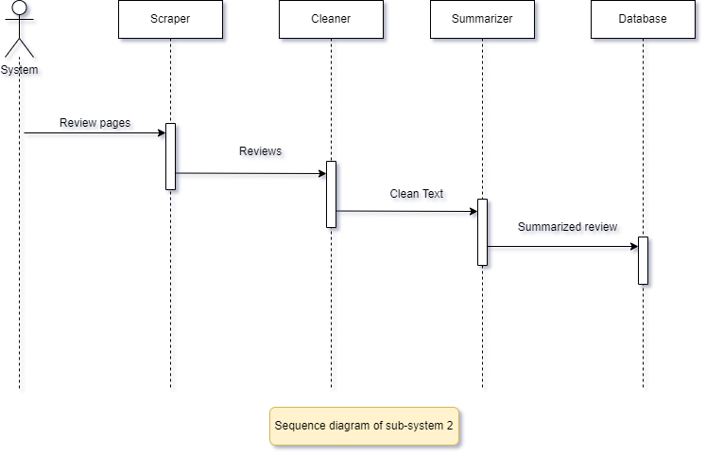

Description:

Our system needs two sub-system to work. For sequence diagram subsystem 1 it works like this:

When user will visit our website, **Website** lifeline will show home page. Our activation occurrence will stay at homepage until the user leave or give a requirement input for his desired product. If the user provides the request the requirement input our **Database** lifeline will match the input with user given data and activation occurrence will remain until it finds the output. In the end our website will provide the output to the customer.

On our sub-system 2 our system will act like an actor. It will collect the review from online pages and **scraper** lifeline will go over each of the laptop’s review and collect information, activation occurrence will remain until it goes to next lifeline which is Cleaner. **Cleaner** will clean the raw revies collected by scraper, purges the collected data of any unwanted portions that are hindrances to the NLP models functionality, and creates clean and usable versions of each review, occurrence will remain until it goes to next lifeline which is Summarizer. The **Summarizer** comprises of the NLP model and the final review for the given laptop. Occurrence will remain until it goes to next lifeline which is Database. **Database** will store the summarized review data in it.

When user wants to see reviews it will provide reviews from Database from Subsystem 2 to subsystem 1.

Class Diagram

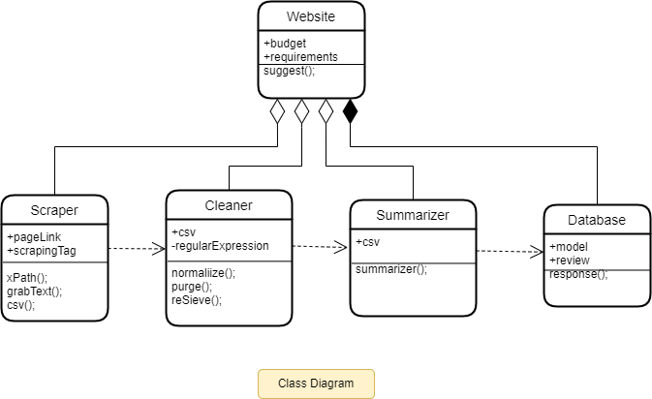

Description:

There are 5 classes: Website, Scraper, Cleaner, Summarize, Database. Where Scraper, Cleaner, summarizer is sub-part of Website class and Database is an important class for Website.

**Scrape**r has 2 attributes and 3 operations. “pageLink” takes all necessary information, comments, review about laptops from different online platforms. “scrapingTag” collects all specification. “xPath()” is a part of selenium which used is for collecting data from websites. “grabText()” collects all important data from the page. “csv()” is used for collects all previous tasks from “Scraper” class.

**Cleaner** has 2 attributes where “csv” is public and “regularExpression” is private attribute. ‘csv’ will come from “Scraper’s” class ‘csv’. ‘regularExpression’ will collect only necessary phrases.

“normalizer()” will convert all texts in common specific format. “purge()” will eliminate all useless data or text from recently filtered data and “reSieve()” is used for removing unnecessary word and filter all purged data.

**Summarizer** has only one attributes “csv” which have all filtered data. “summarizer()” will re-arrange and organize all data in proper way and create a single summary including all necessary information about laptops.

**Database** is the store house of all laptop information which will be upgrade every day. It has 2 attributes “model”, “review” which contains a summary review for a specific model laptop. And display it to the user.

4. Conclusion

Throughout the semester we have designed our system based on what we have learnt in the class. The diagrams that we have learnt have been useful in laying out a proper planning for building the eventual system. Some of the diagrams have proven to be challenging in adaption for this particular system as it required them to address the whole system as culmination of two subsystems. Going forward, the lessons of this course would prove to be immensely helpful in completing the project in the coming semesters, and also for other projects as well.

# **References:**

Sentiment analysis is the analysis of customer’s opinions, expressions, likes and dislikes towards products, organizations or services. These papers primarily work on this.

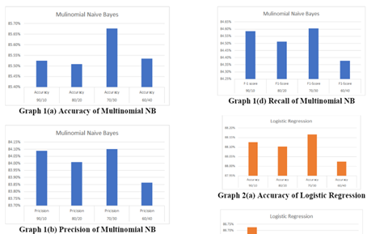**A. Product Recommendation using Sentiment Analysis of Reviews: A Random Forest Approach**

*Authors: Gayatri Khanvilkar, Prof. Deepali Vora*

Ø Tries multiple approaches

Ø Based on various products

Ø Classifies the content based on polarity

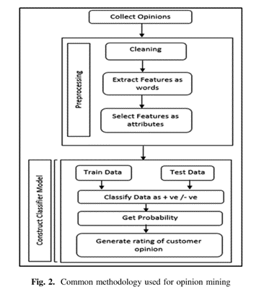

**B. Data Analysis: Opinion Mining and Sentiment Analysis of Opinionated Unstructured Data**

*Authors: Harshi Garg, Niranjan Lal*

Ø Provides a more structurally defined approach

Ø Goes deeper into the topic of sentiment analysis

Ø Discusses both approach of Machine learning and

Lexicon-based

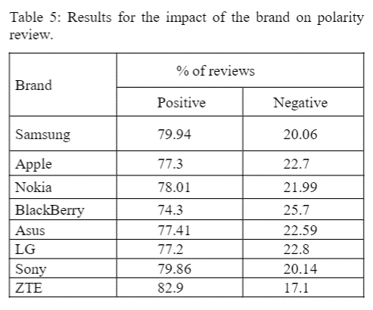

**C. Comparison of Naïve Bayes, Support Vector Machine, Decision Trees and Random Forest on Sentiment Analysis** *Authors: Márcio Guia, Rodrigo Rocha Silva, Jorge Bernardino*

Ø Works on a similar dataset: mobile phones

Ø Little outdated

Ø Viable with adjustments

**D. Tell Me What You Want: A Recommender System Based on Customer Preferences and Product Reviews**

*Author:  Josh Barua*

This is an abandoned work found on GitHub that can be used as a base for one portion of the project.

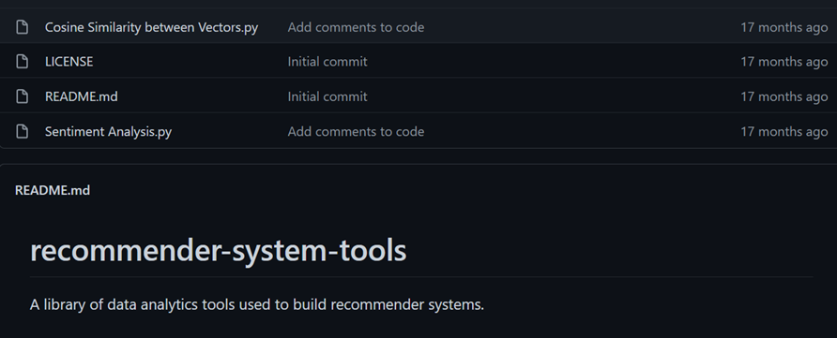

# **Complex Engineering Problem & Mapping:**

* **How Ps are addressed through the project:**

|  |  |  |  |  |
| --- | --- | --- | --- | --- |
| **Ps** | **Attribute** | **How Ks are addressed through the project** | **COs** | **POs** |
| **P1** | Depth of Knowledge Requirement | Our project requires Machine learning (K2), rigorous study of existing projects(K8), surveys & reviews from users, monitoring new products (K3, K4), knowledge of web-development(K6), data collection & analysis(K5). | CO1  CO2  CO3  CO7 | PO1  PO2  PO3  PO5 |
| **P3** | Dept of Analysis Requirement | Users’ requirements, device feather's data, users demand etc. | CO4  CO7 | PO2  P12 |
| **P4** | Familiarity of Issues | We need to Analyze & implement various programming knowledge and skills to fix many issues | CO7 | PO3  PO9 |
| **P7** | Interdependence | Our project involves interdependent components such as requirement analysis, designing, back-end, front-end, software testing, dataset etc. | CO2  CO7 | PO2  PO10 |

* **How As are addressed through the project:**

| **Ps** | **Attribute** | **Ps are addressed through the project** |
| --- | --- | --- |
| **A1** | Range of Resources | Device's data is collected. Web framework is an important resource for this project. It engages diverse resources including various designing tools. |
| **A2** | Level of Interaction | Successful interaction between Web framework and NLP |
| **A5** | Familiarity | Our project deals with Internet users. |

* **How COs are addressed through the Project:**

| **Ps** | **CO Statements** | **Corresponding POS** |
| --- | --- | --- |
| **CO1** | Identifying a real-life problem that can be transmitted to an engineering or computing solution through design, development and validation. | PO4  PO10  PO12 |
| **CO2** | Identify, formulate and analyze a real world compels engineering problem based on requirement | PO2  PO3 |
| **CO3** | Design/Develop a working solution on a complex software-intensive system and verify and validate the solution using industrial state of the practice, that indicates a high-quality software-intensive system | PO1  PO5  PO11 |
| **CO4** | Use a modern/popular IDE to test complex software-intensive systems. | PO7 |
| **CO7** | Work as a team and fulfill individual responsibility | PO9 |

|  |  |  |  |
| --- | --- | --- | --- |
| **CO** | **CO Statements:** | **Appendix-1** | **Appendix-2** |
| CO1 | **Apply** the Engineering knowledge to provide a working solution on a complex engineering problem and submit a mapping. | 1 | 1/Apply |
| CO2 | **Identify, formulate, and analyze a** real-world complex engineering problem based on requirement analysis. | 2 | 1/Analyze |
| CO3 | **Design/Develop** a working solution on a complex software intensive system and verify and validate the solution using industrial state of the practice, that indicates a high-quality software-intensive system | 3 | 1/Apply |
| CO4 | **Use** a modern/popular IDE to test complex software-intensive systems. | 5 | 1/Apply |
| CO5 | **Identify** societal, health, safety, legal and cultural issues related to the project. | 6 | 1/Analyze |
| CO6 | **Practice** concepts of professional ethics, confidentiality, industrial standards. | 8 | 3/Valuing |
| CO7 | **Work** as a team and fulfill individual responsibility. | 9 | 1/Apply |
| CO8 | **Communicate** effectively through presentation and write effective reports and documentations on the project. | 10 | 1/Apply |
| CO9 | **Apply** project management principles using Version Control System, and appraise project operating cost, financial risk analysis for complex software intensive systems. | 11 | 1/Apply |
| CO10 | **Recognize** the need for, and have the preparation and ability to engage in independent and life-long learning for art of project management, distributed and collaborative software  development and risk analysis for developing complex  software-intensive systems. | 12 | 1/Apply |

|  |  |  |
| --- | --- | --- |
| **No.** | **PO** | **Differentiating Characteristic** |
| 1 | Engineering Knowledge | Breadth and depth of education and type of knowledge, both theoretical and practical |
| 2 | Problem Analysis | Complexity of analysis |
| 3 | Design/ development of solutions | Breadth and uniqueness of engineering problems i.e., the extent to which problems are original and to which solutions have previously been identified or codified |
| 4 | Investigation | Breadth and depth of investigation and experimentation |
| 5 | Modern Tool Usage | Level of understanding of the appropriateness of the tool |
| 6 | The Engineer and Society | Level of knowledge and responsibility |
| 7 | Environment and Sustainability | Type of solutions. |
| 8 | Ethics | Understanding and level of practice |
| 9 | Individual and Team work | Role in and diversity of team |
| 10 | Communication | Level of communication according to type of activities performed |
| 11 | Project Management and Finance | Level of management required for differing types of activity |
| 12 | Lifelong learning | Preparation for and depth of Continuing learning. |